**UiPath Integration Service: Introduction**

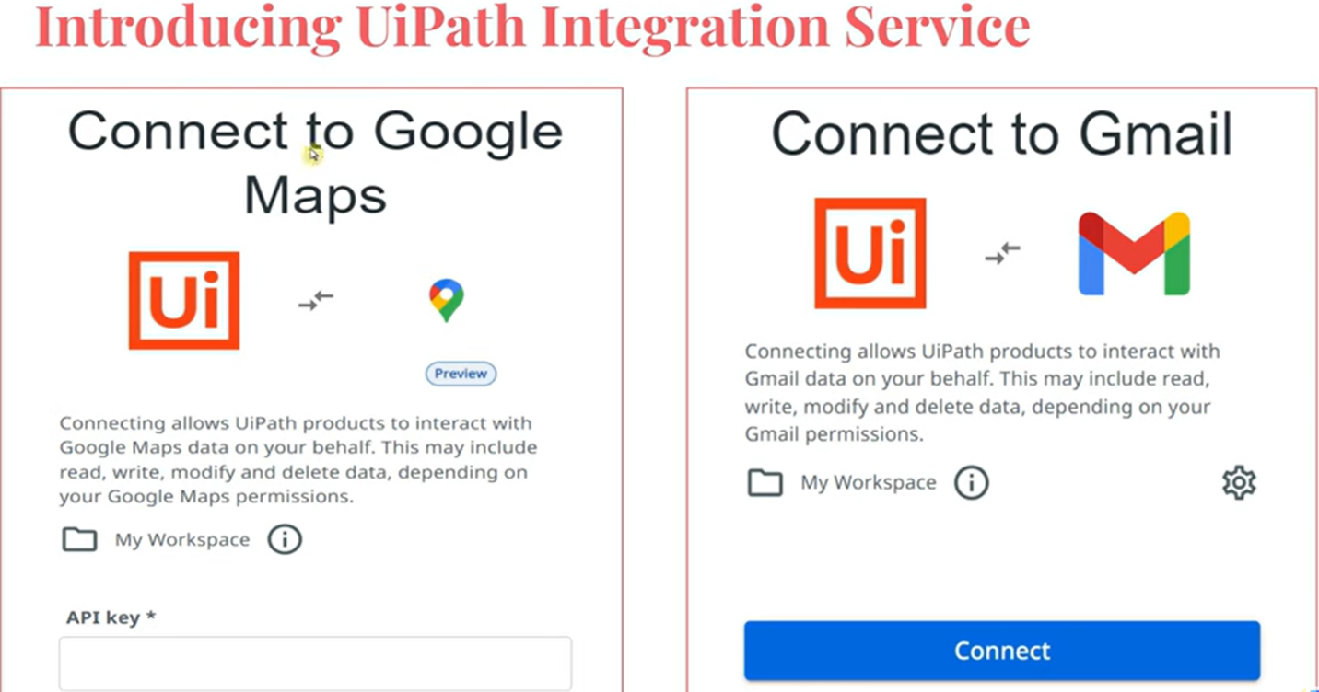

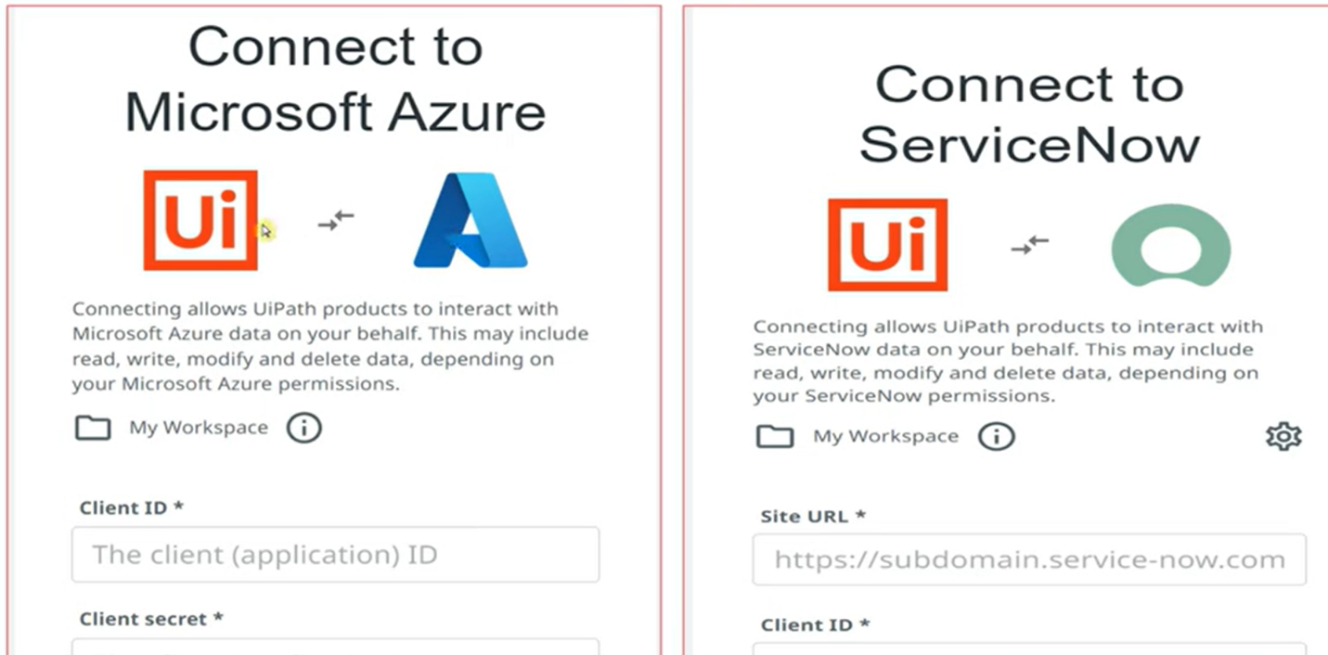

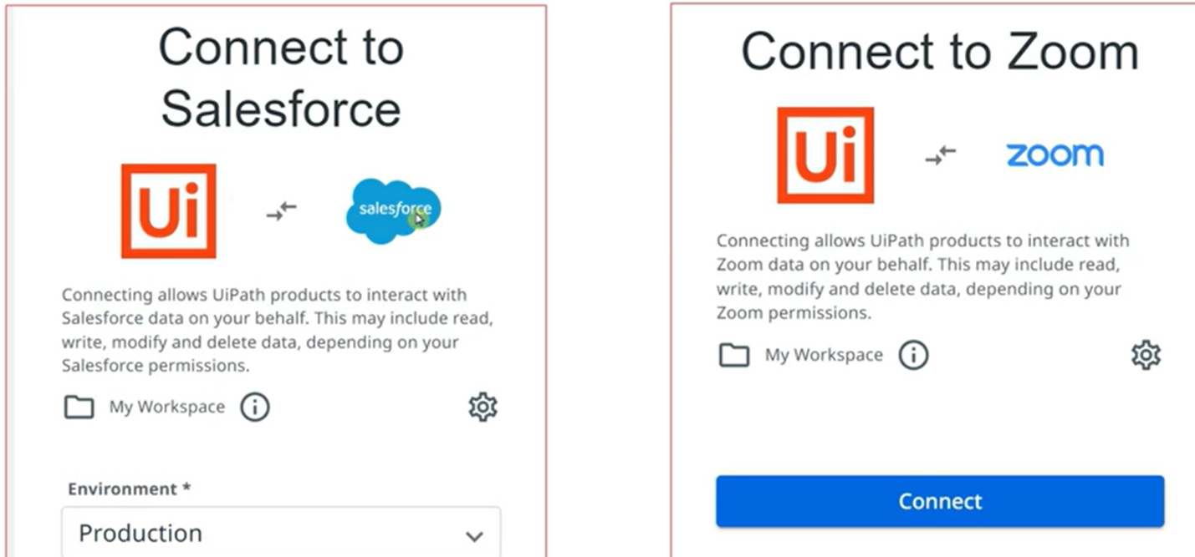

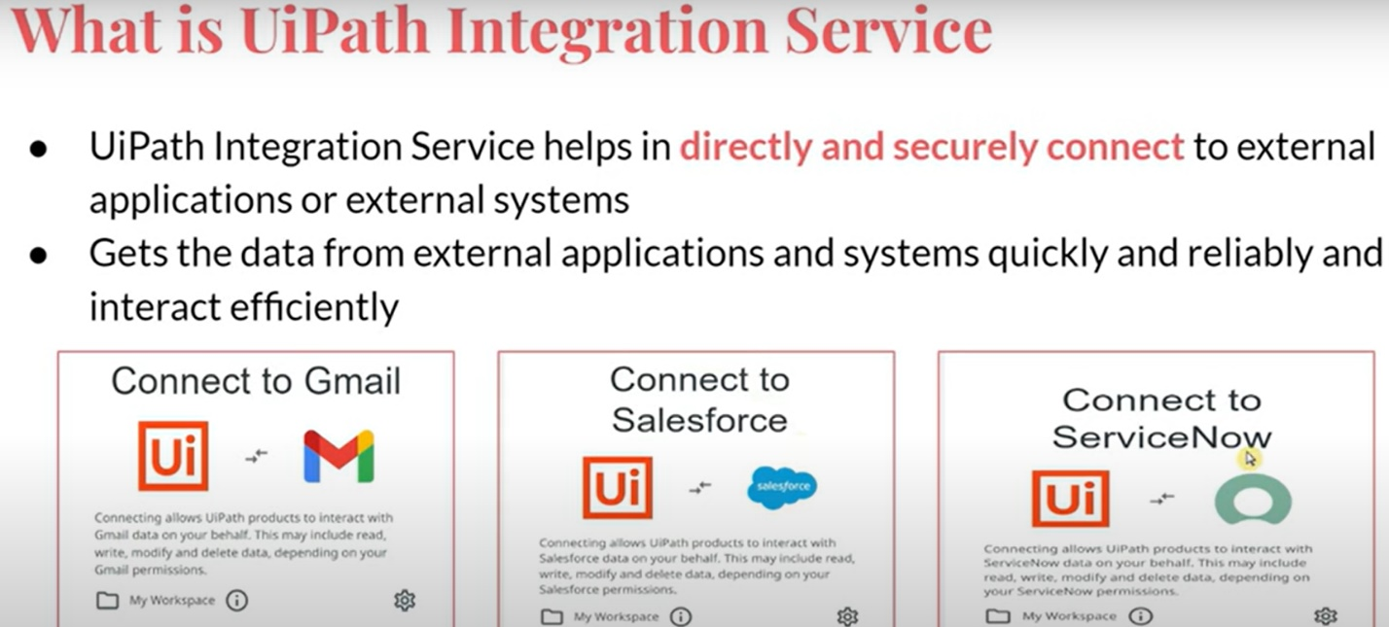

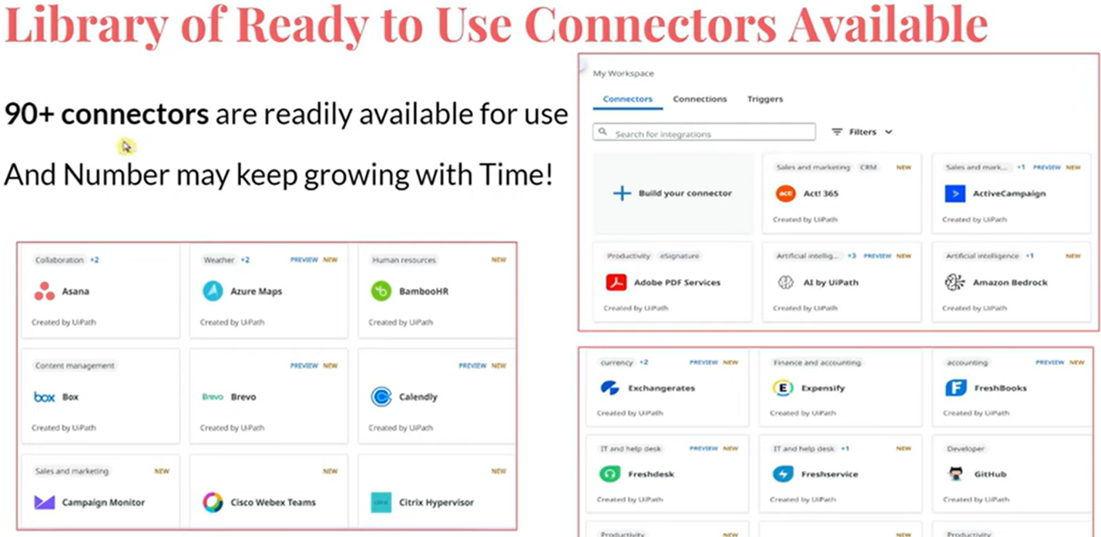

If you need to integrate UiPath with your internal application (not accessible outside your organization), you can build your own connector.

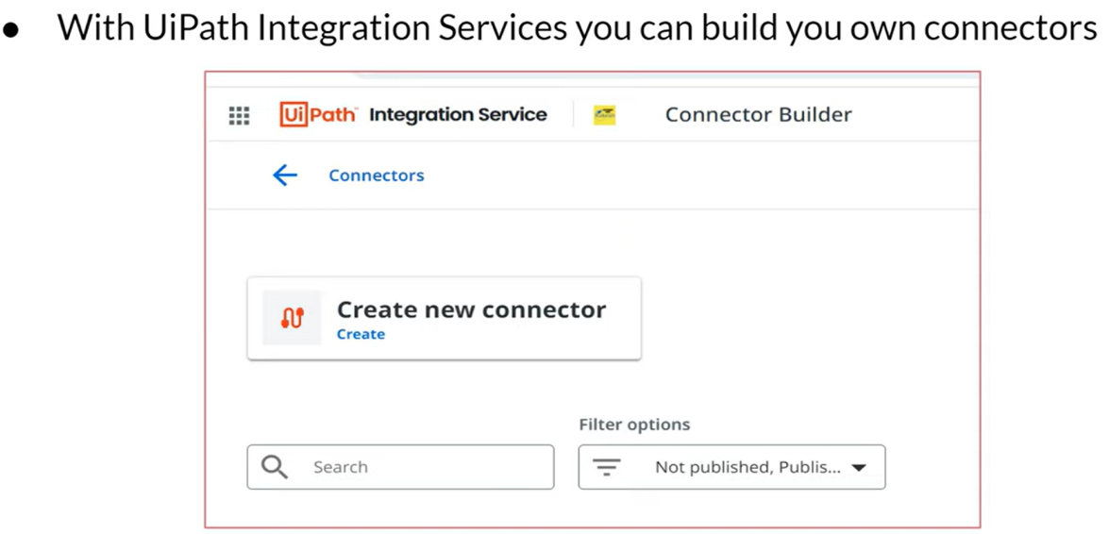

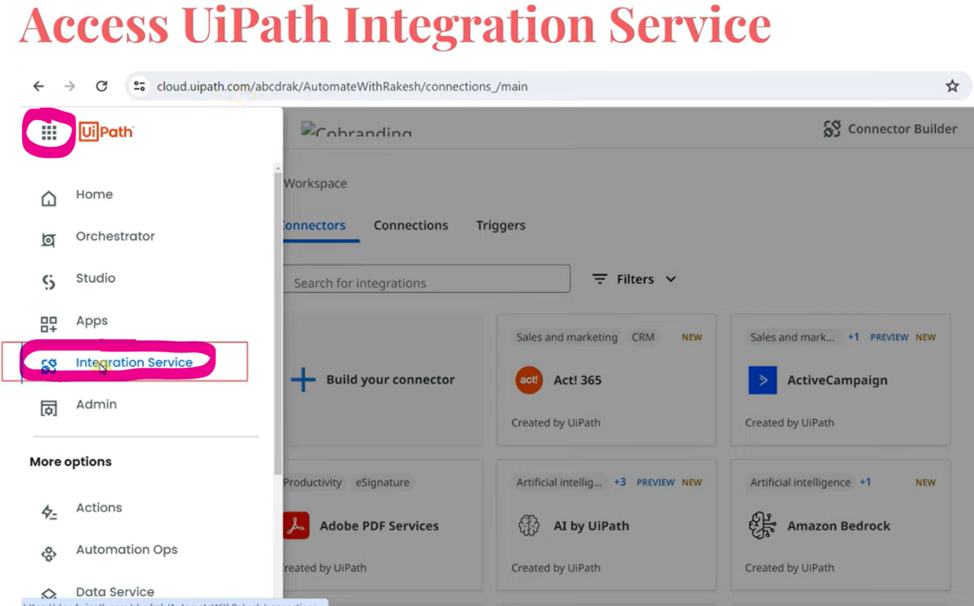

By default, it lands to Connector tab where you can find 90+ number of connectors readily available like salesforce, SAP, slack, Snowflake, zoom, Vmware, workday etc.

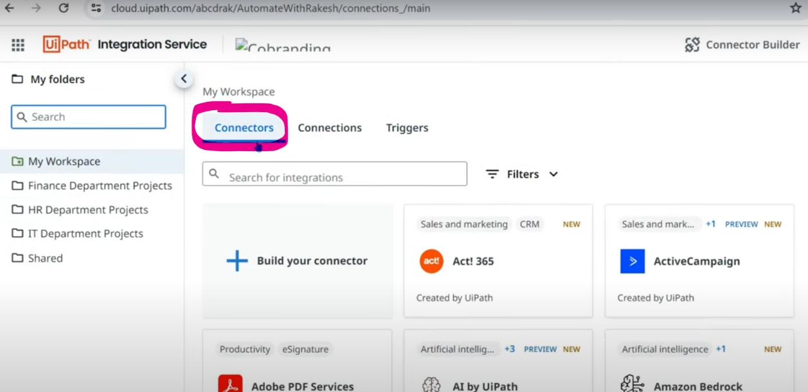

Let's click on 1 connector, example GMAIL & we can see connect button like below.

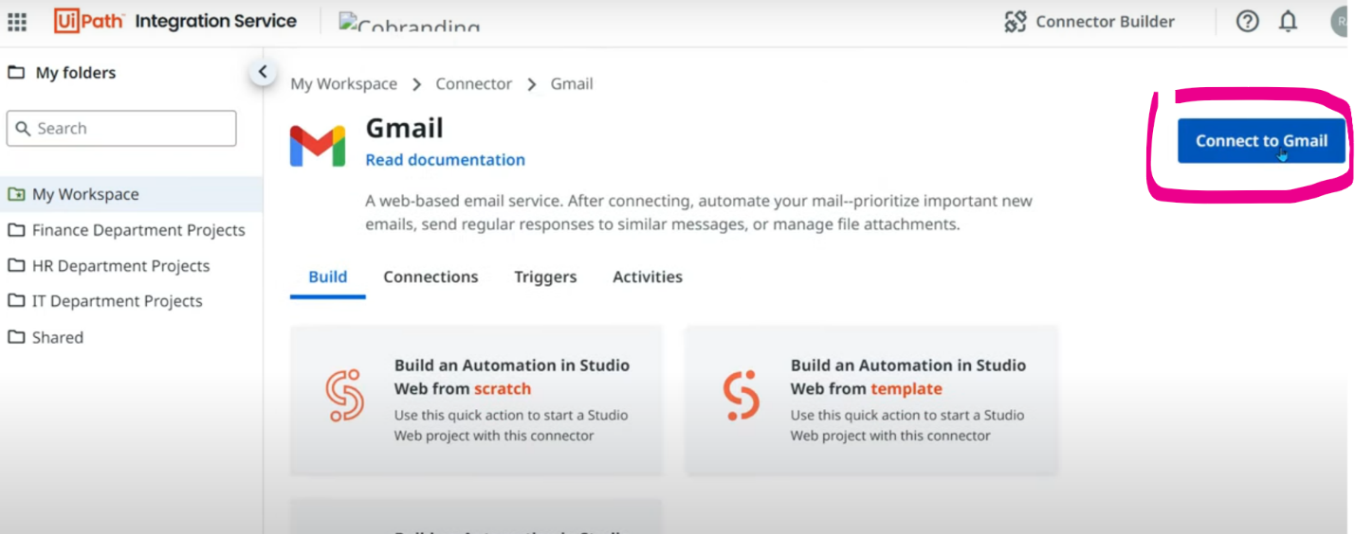

It navigates to a page to connect & sign in like below.

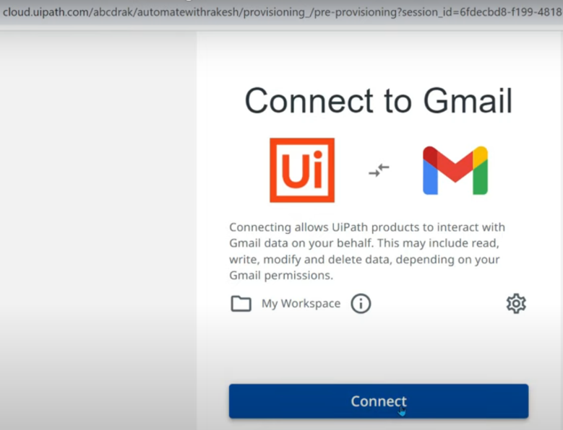



It requests for access permissions like below.

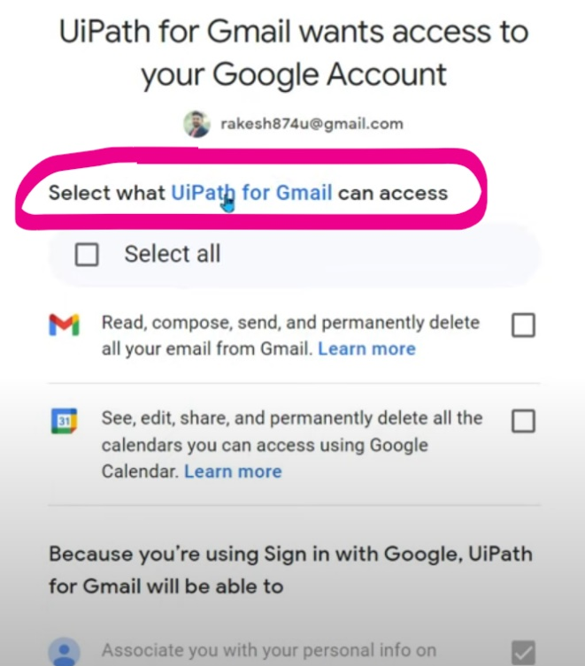

**NOTE: Connection steps will be slightly different & depends on the connector entirely. Microsoft Azure connection requires different set of data like below unlike google. Each connector works in a different way.**

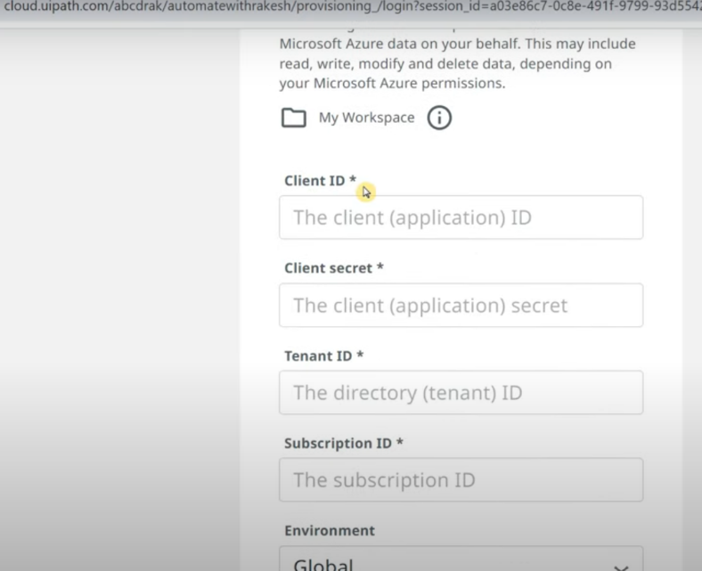

3 Components of Integration Service are:

1. **Connectors**: Contains 90+ connectors.
2. **Connections**: Displays list of connections we have made.
3. **Triggers**: From trigger we can start an automation, example, the moment I receive Gmail, there has to be process in orchestrator that automatically gets triggered. Based on certain events in external application, we can set the trigger which can start an automation.

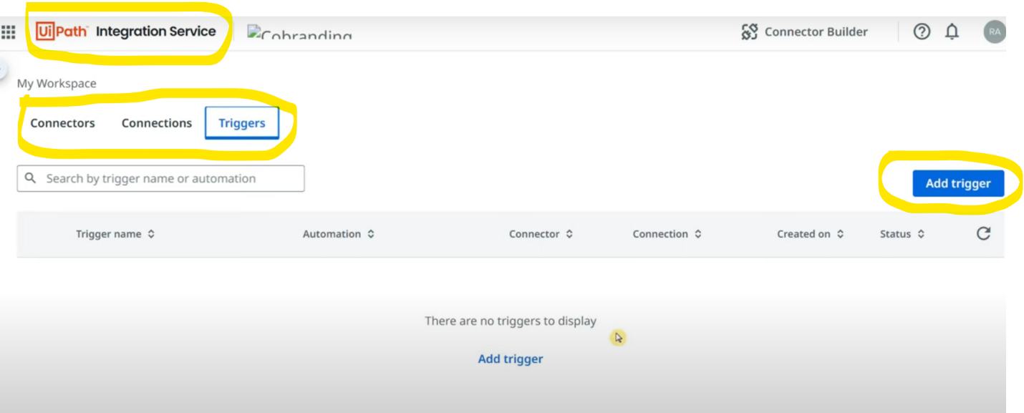

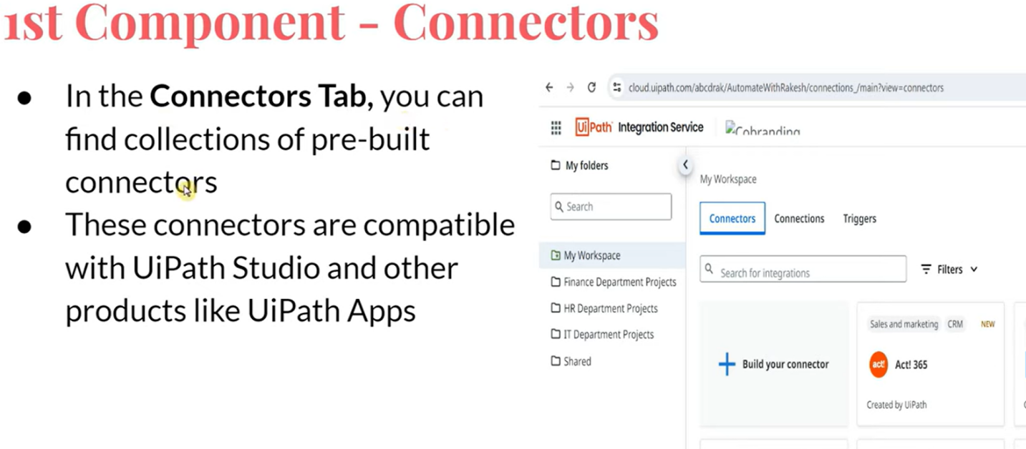

Once connection is built, let's say we need to perform some action with that connected application like creating incident or getting records or anything, we need to install the required activity package from manage packages in uipath studio to get the dedicated activities for that connection.

In UI automation there are many steps like Open browser, click on required tabs and then get the records but here instead of performing so many UI activities, Uipath directly communicates with the external application & get the data in just 1 activity.

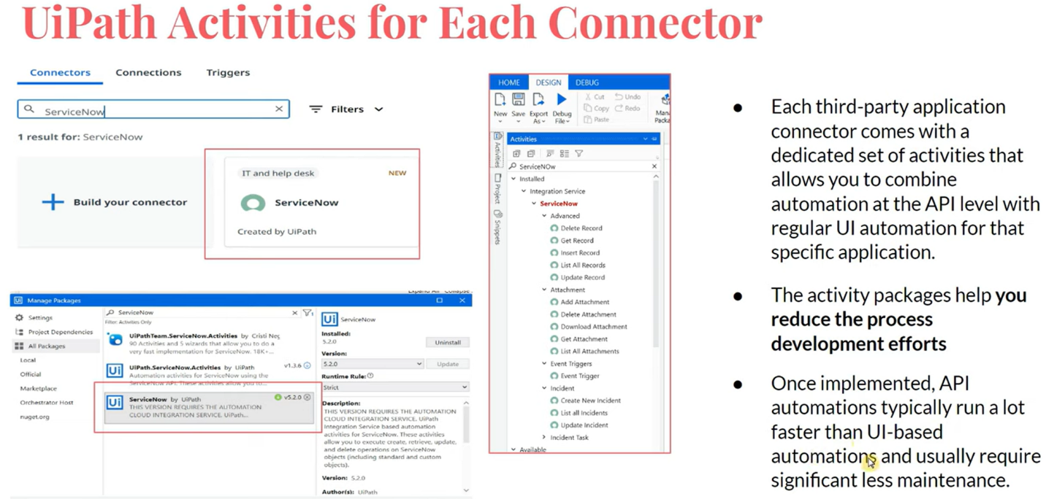

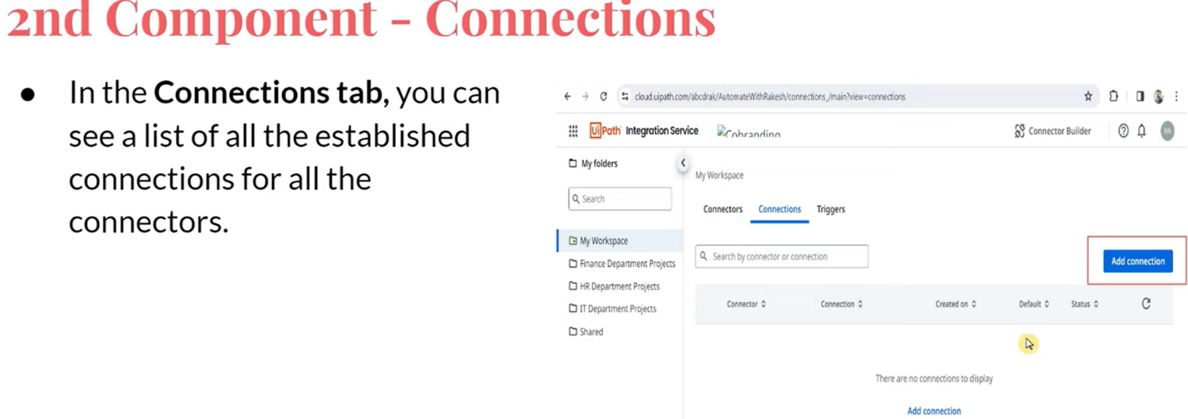

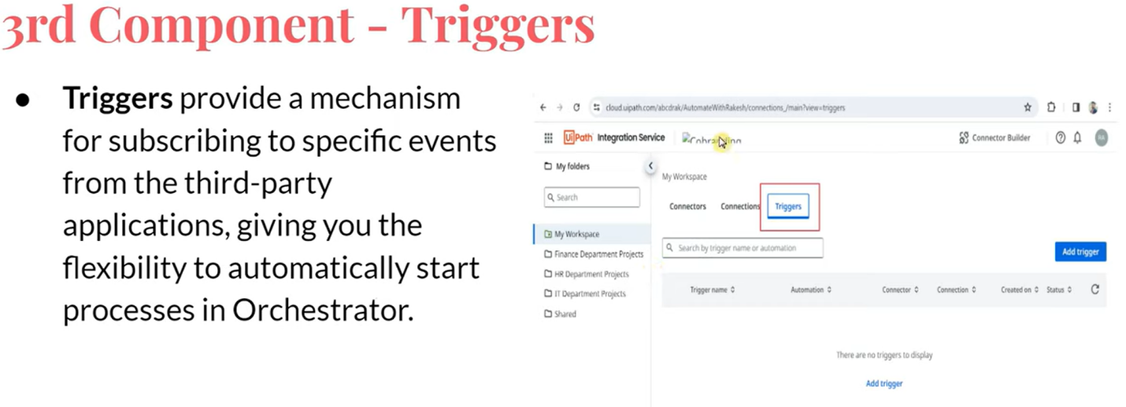

**UiPath Integration Service: Integrate Microsoft OneDrive & SharePoint**

**NOTE**:

1. Connection to be established on Integration service.
2. Install related packages on studio
3. Folder (MODERN) selected during connection establish should match on the orchestrator & uipath studio

After building connection, we can perform lot of activities like creating folder, uploading file etc. Also you can take advantage of events like if someone has uploaded a file, we can kickstart an automation based on the events.

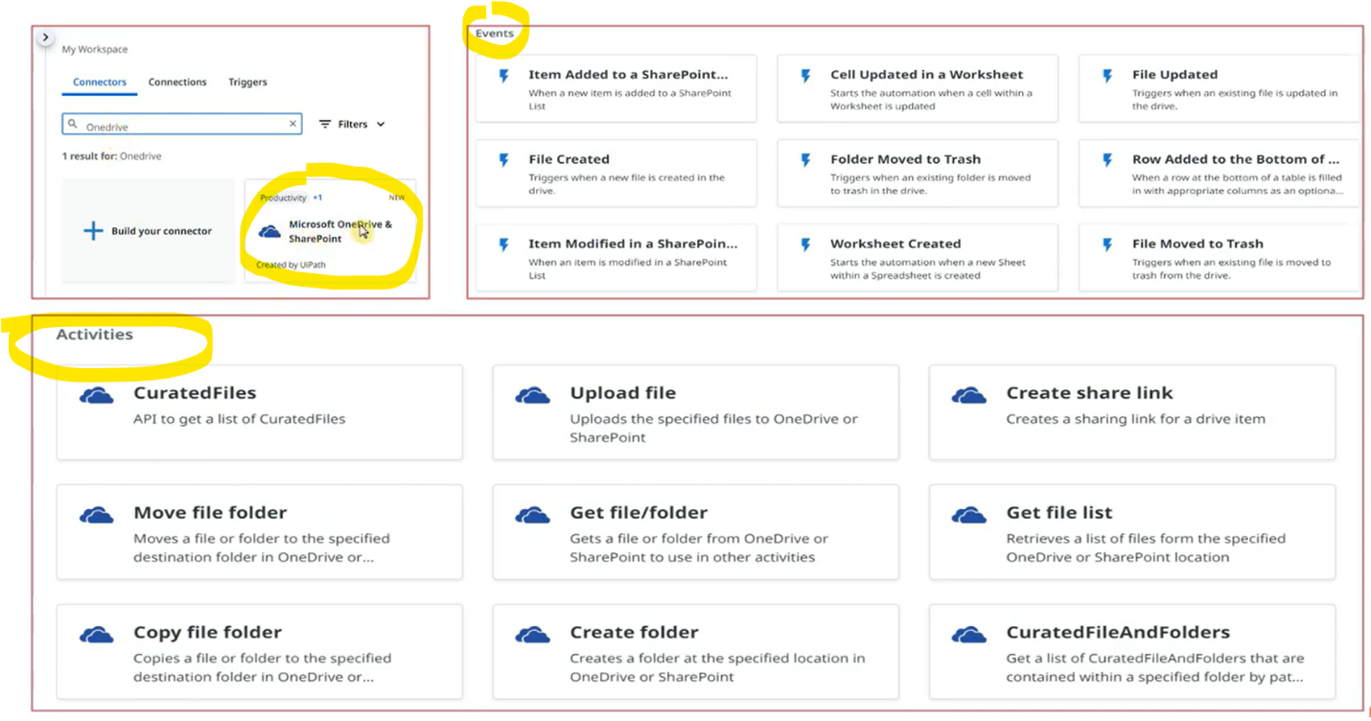

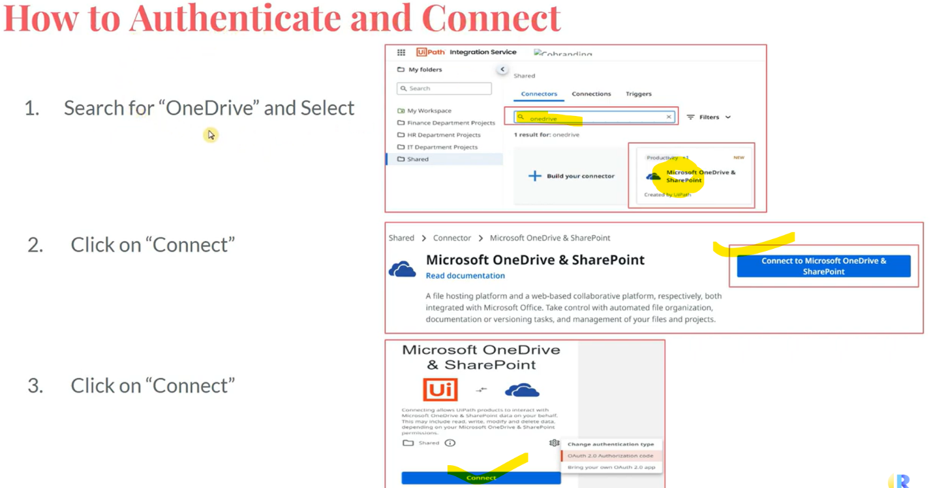

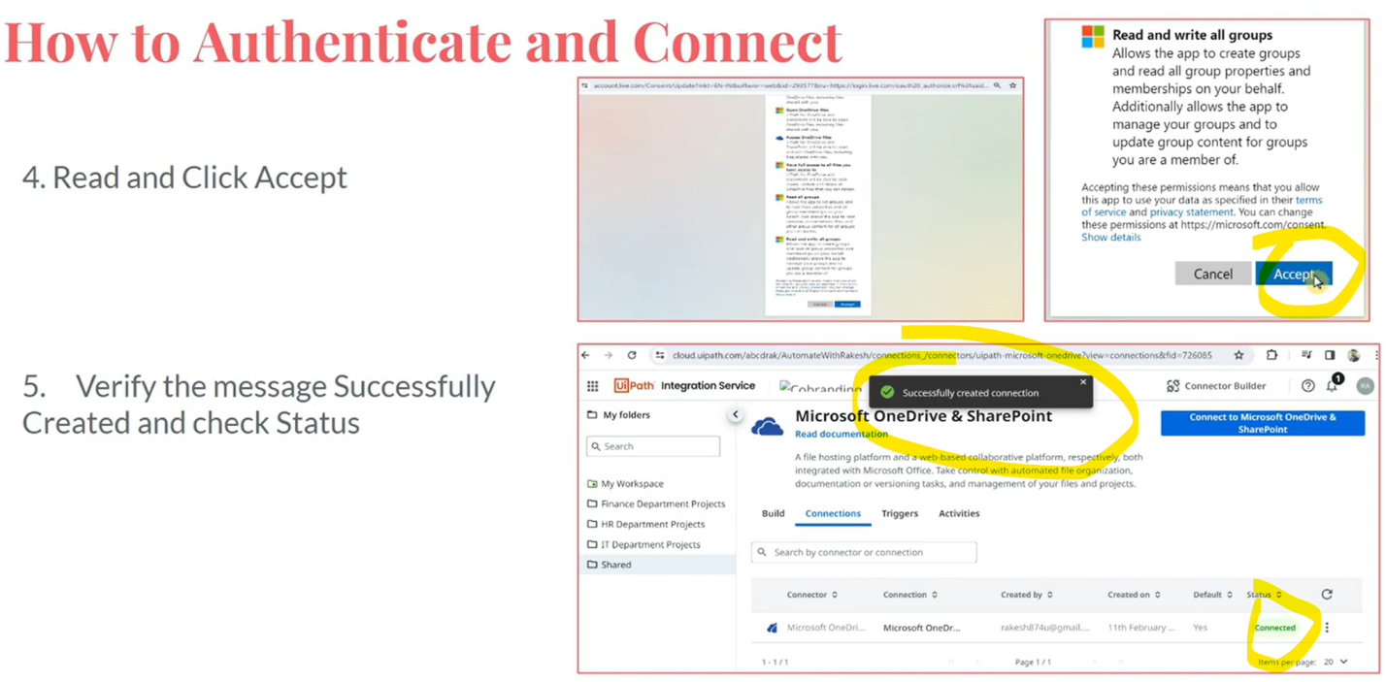

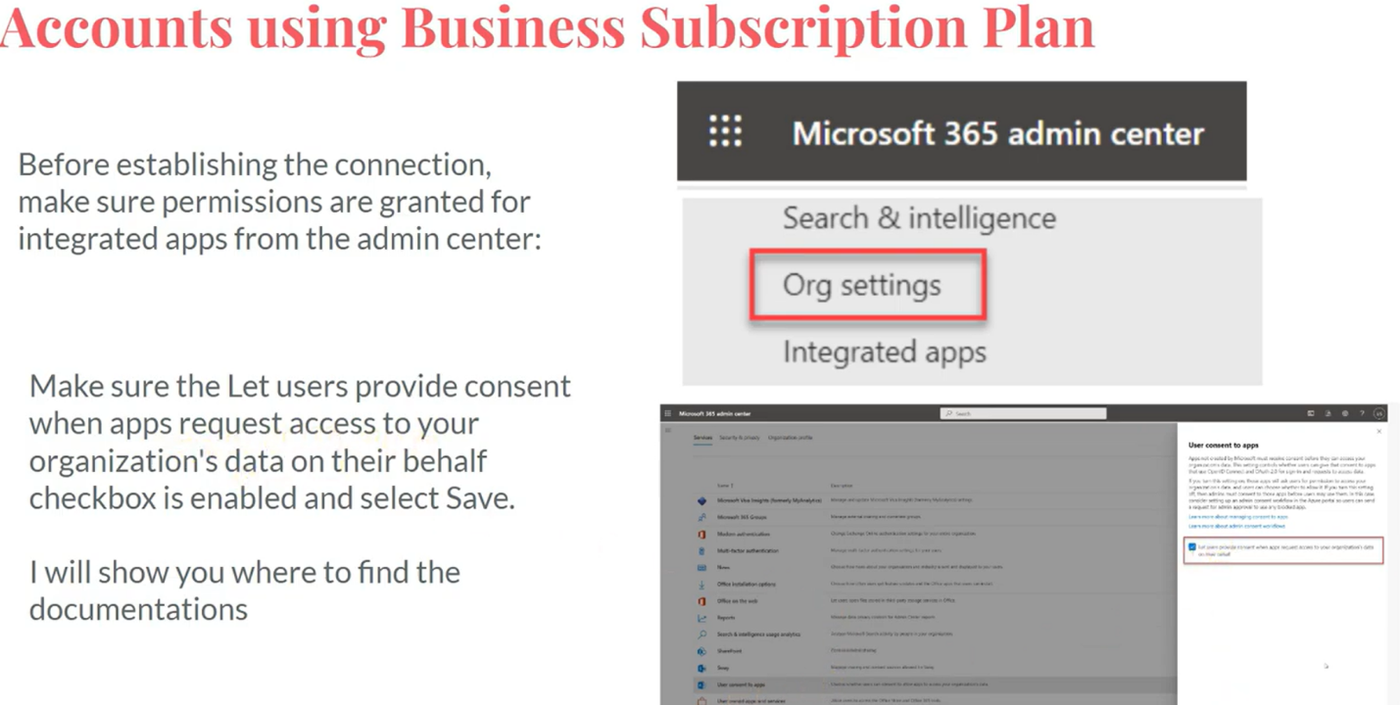

Polling means - If I'm using event trigger (File created), polling checks for 5 every minutes (default time) if file has created or item has added to SharePoint, it checks for the events every 5 mins.

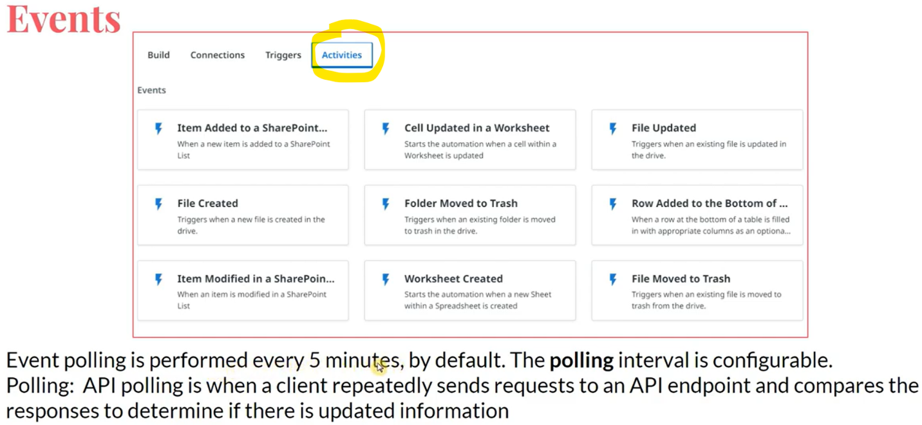

To build an automation, we should also install required packages, in this case we need to install Microsoft365 package as we are integrating with Microsoft SharePoint & OneDrive.

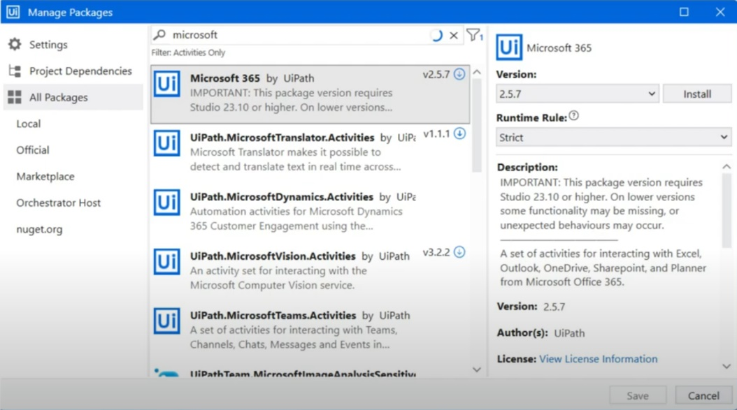

In orchestrator, go to Integration service.

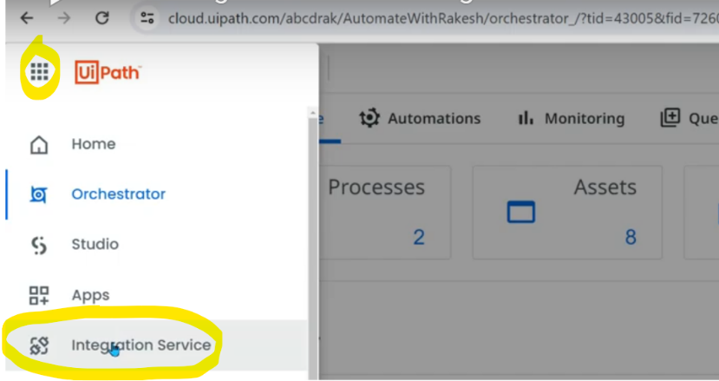

Select any folder (MODERN only), & search for OneDrive connector.

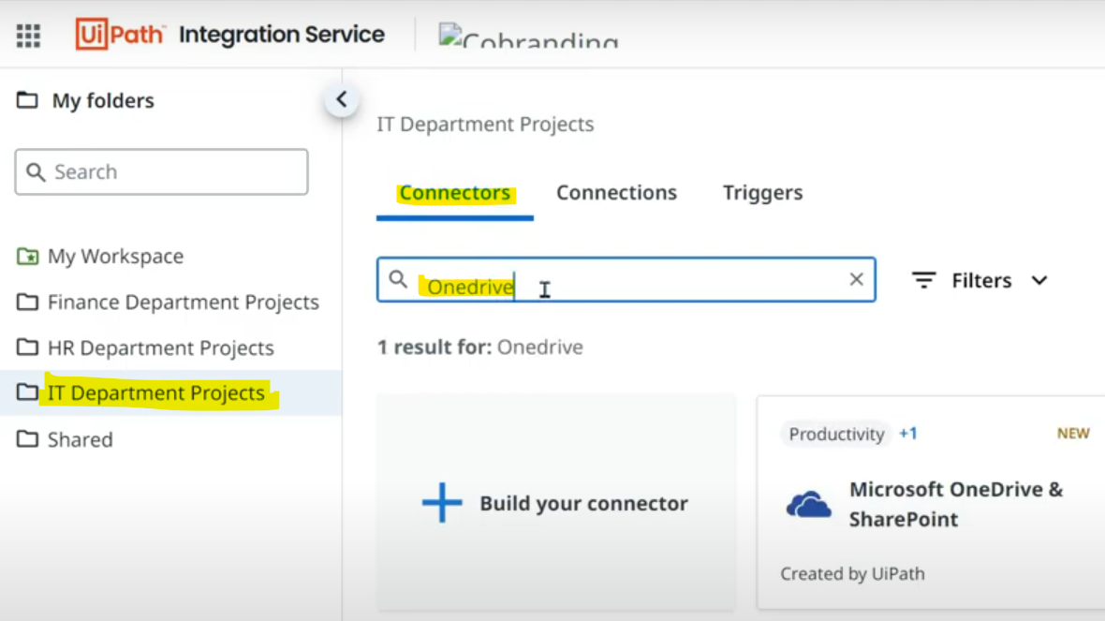

If you click on above card "Microsoft OneDrive & SharePoint" it takes us to below page, click on "Read documentation". This briefs us about this connector & business subscription plans for this connector & many more.

Before clicking on Connect blue button, login your OneDrive & keep it open.

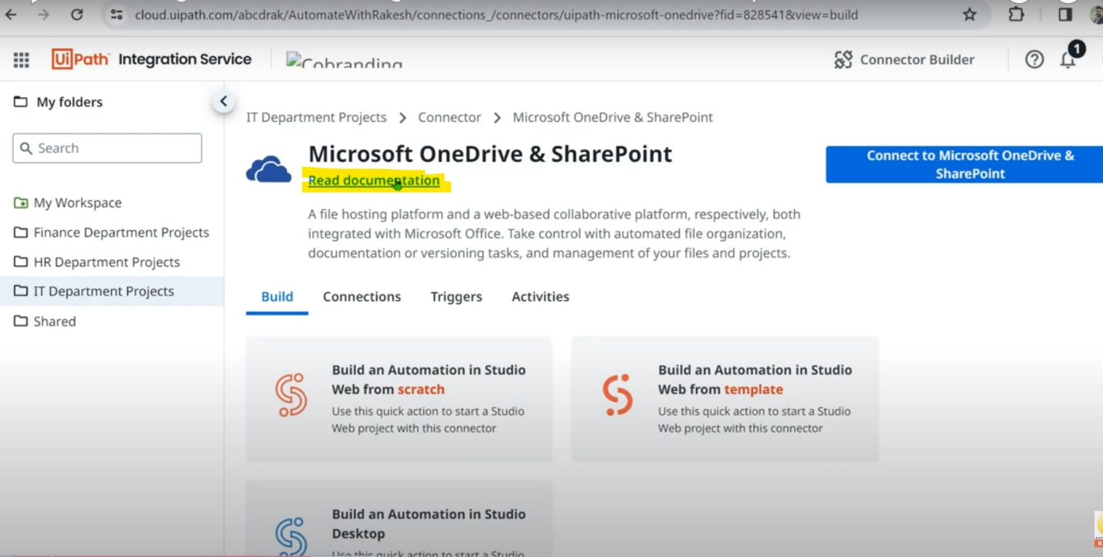

Authentication window opens where we can see the folder we selected in orchestrator before connecting.

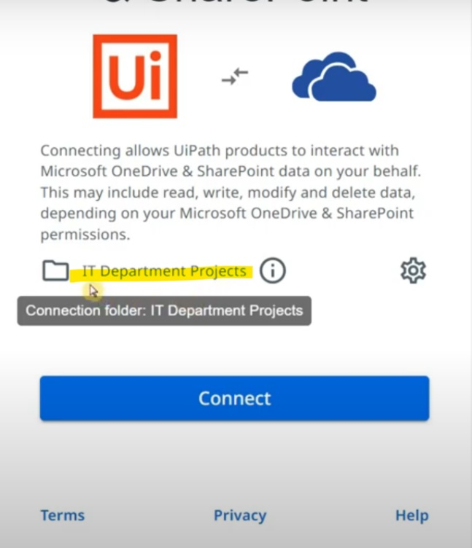

The same above folder must be selected in studio as well. If you are unable to see the folder, click on refresh.

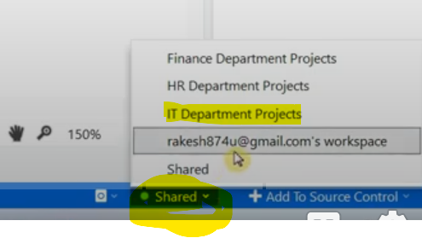

Click on above settings button & you ca find 2 authentication types. Select the default one without making any changes & click on Connect.

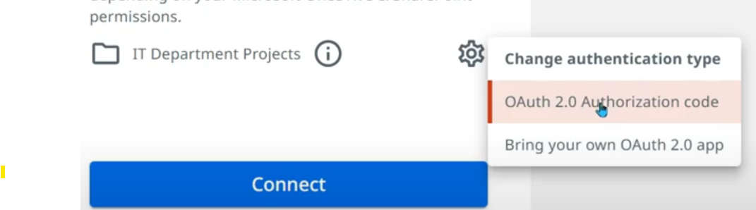

It takes few mins & it shows the below.

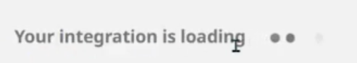

Once connected, we can see it like below.

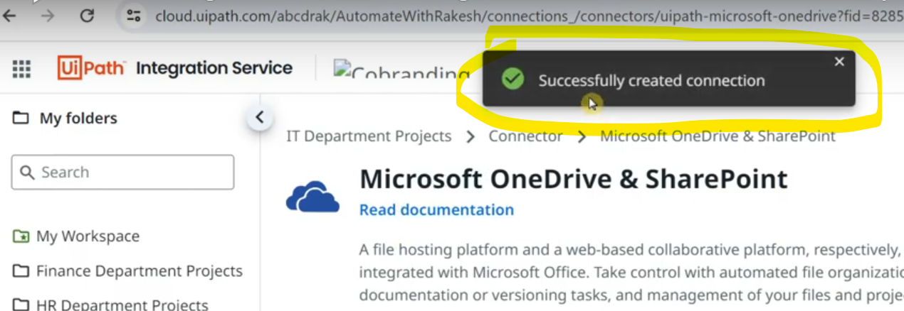

Now we can see the connection under "Connection" tab with status connected.

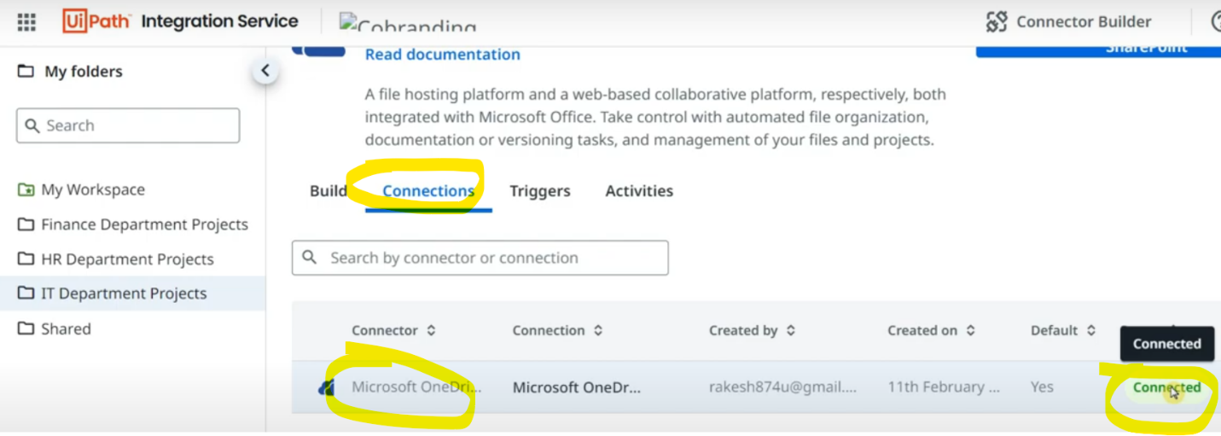

Let's build an automation now.

1st step is to install appropriate packages. Type "Microsoft 365" & install.

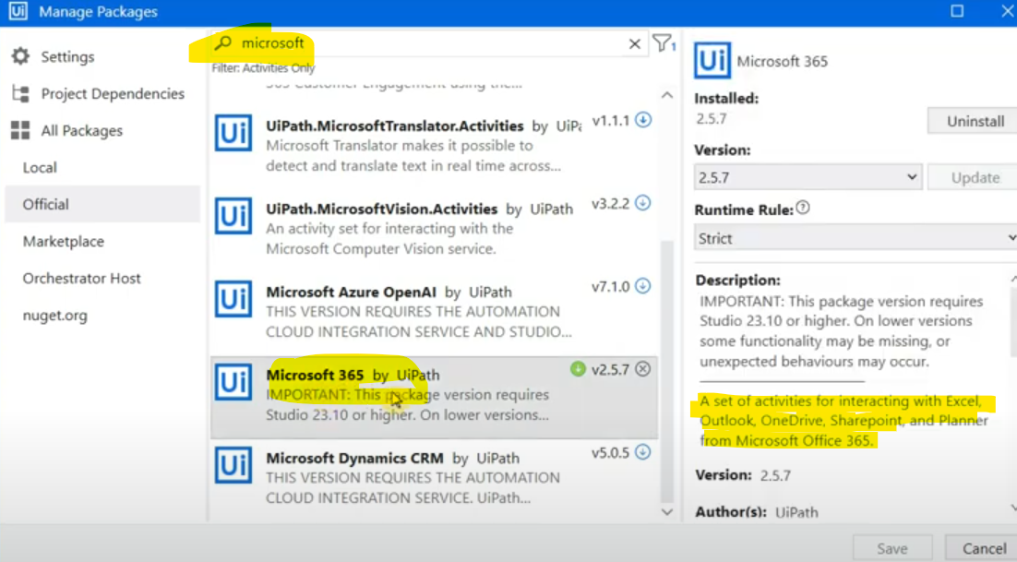

Verify like below which means package is installed in this workflow.

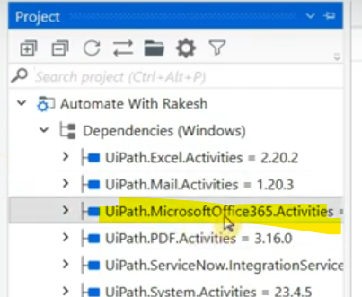

All the below activities are OneDrive related.

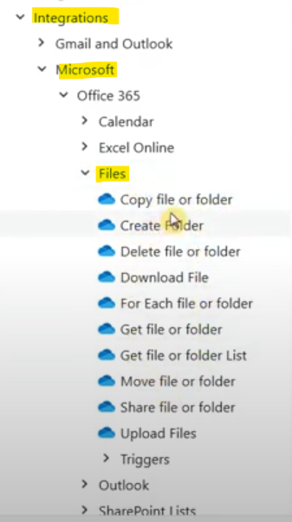

Suppose we use this activity.

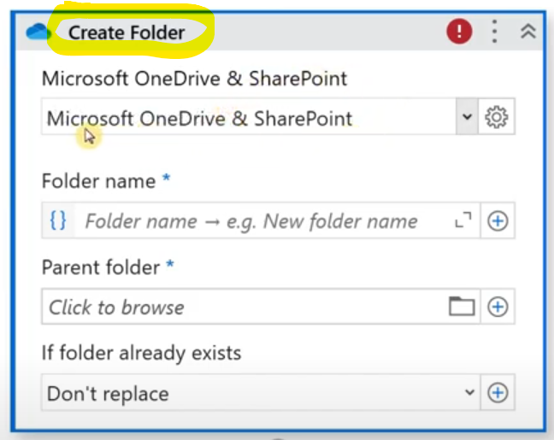

In the drop down it shows the folder we selected during connection creation in integration services.

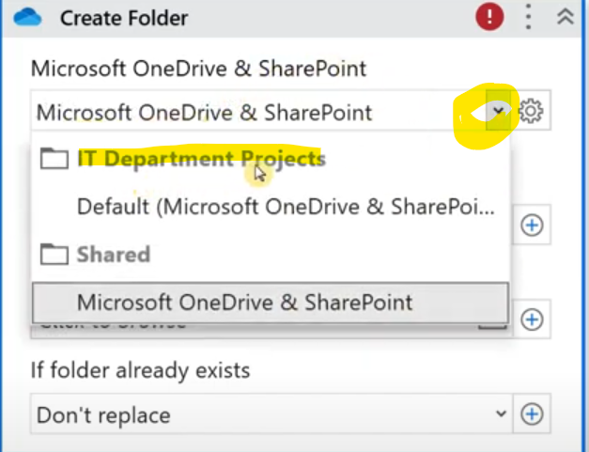

If you click on "Parent folder" field, it is capable of showing all the folders associated with my OneDrive account.

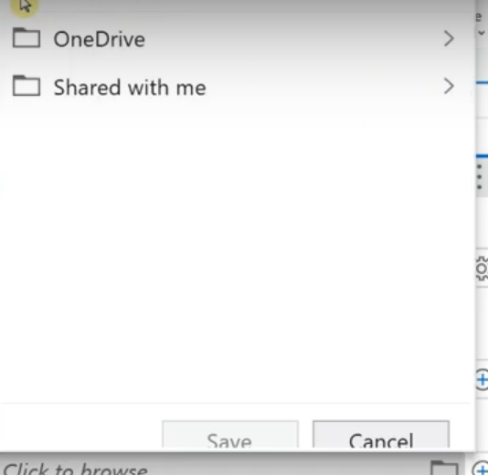

If folder already exist, we have 2 options - Don’t replace & auto rename.

Our purpose is to create folder so give it a name "Test123". Once you run, you can see the folder got created in your OneDrive, refresh page if you don’t see. There are lot other activities to explore.

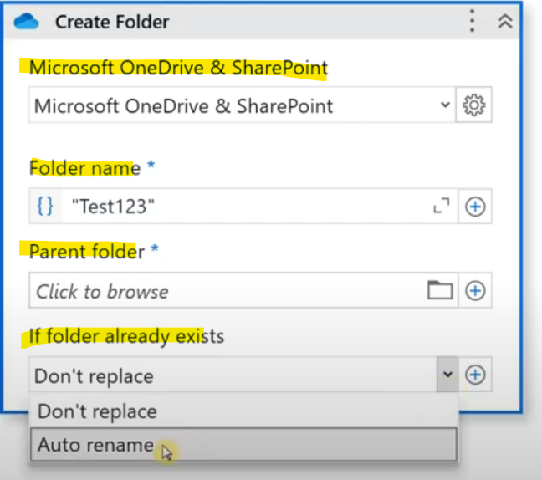

Now, I don’t have to create activities to login OneDrive or enter username or select folder on UI. I've just established connection on Integration service & selected right folder on uipath studio, installed package & using dedicated activities & giving them the inputs. This will shorten our development time.

Go to "Manage triggers" in connections. OR you can click on "Add Trigger" in Trigger tab.

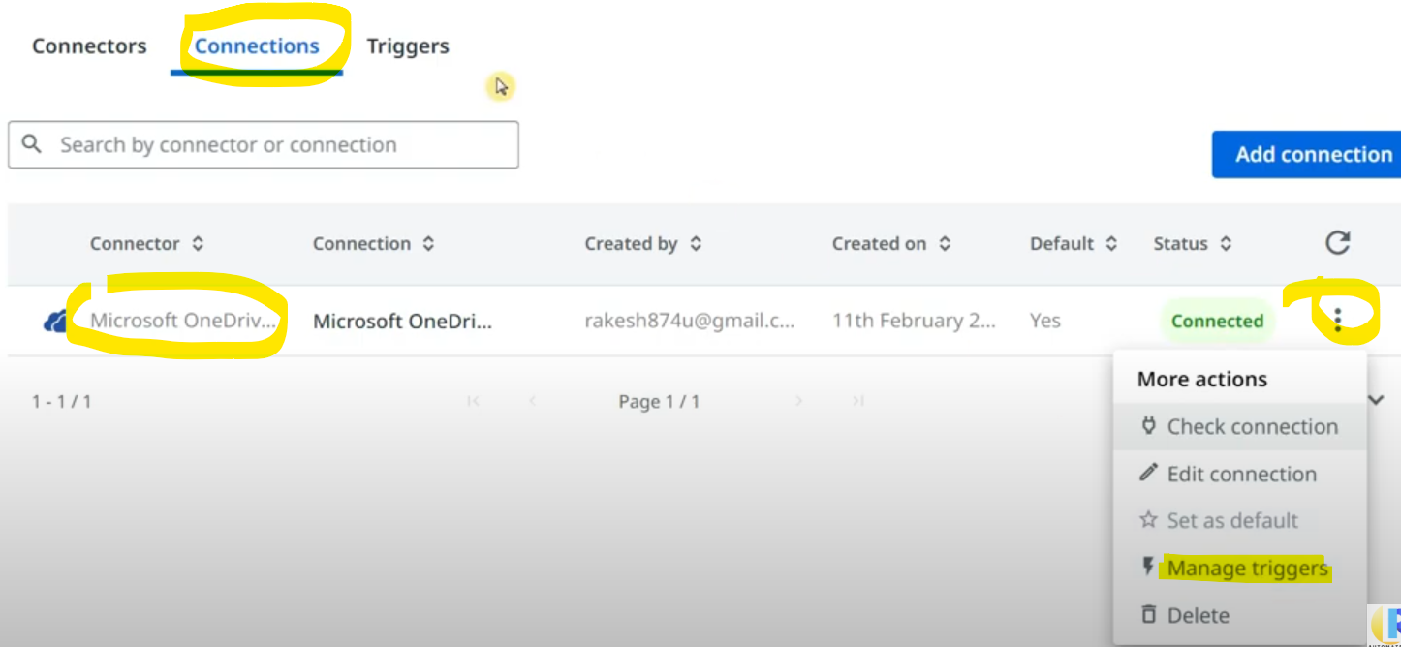

Now click on "Add Trigger"

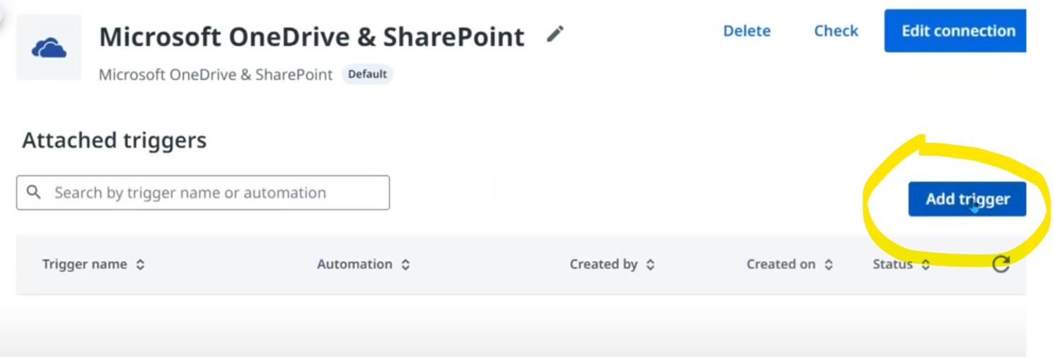

It automatically selects the connector name & type as we have created through the connection.

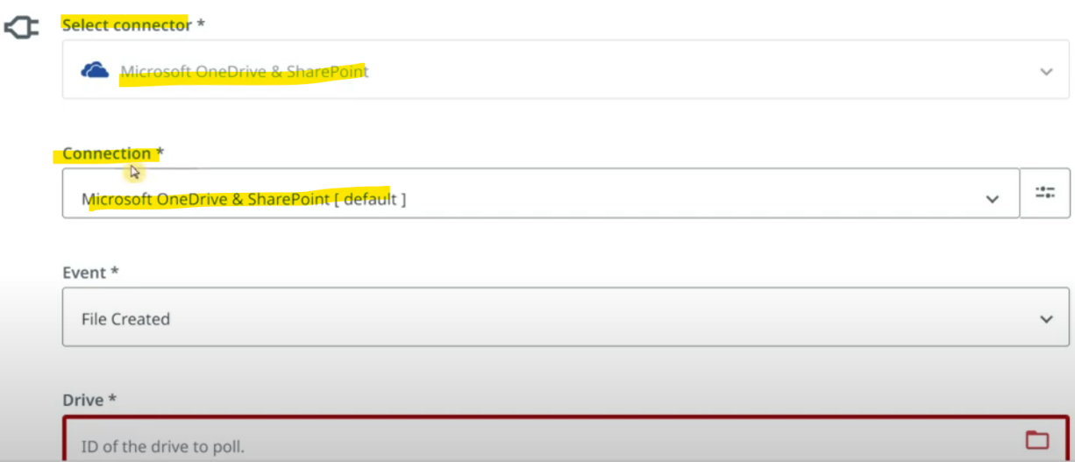

In "Event" choose when the event when you want your automation to get triggered. Based on your requirement, choose.

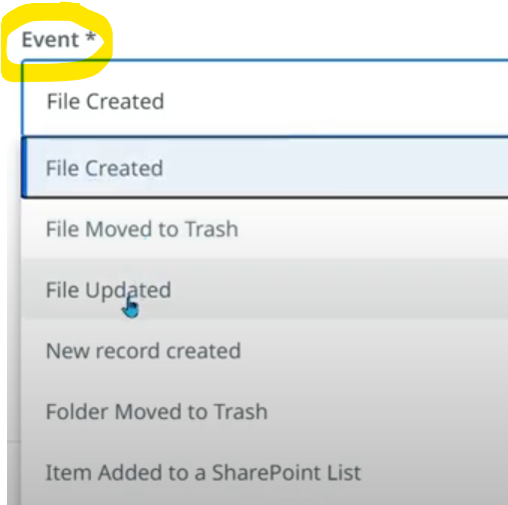

In "Drive" field, choose OneDrive & in "Select Automation" choose the automation project you want to run when file is added to your OneDrive.

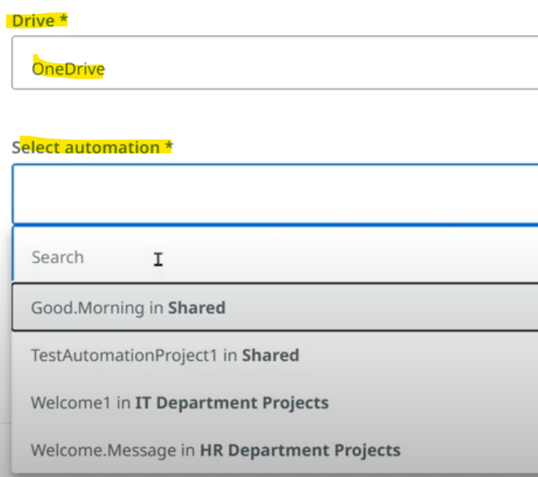

Select the Runtime license you have.

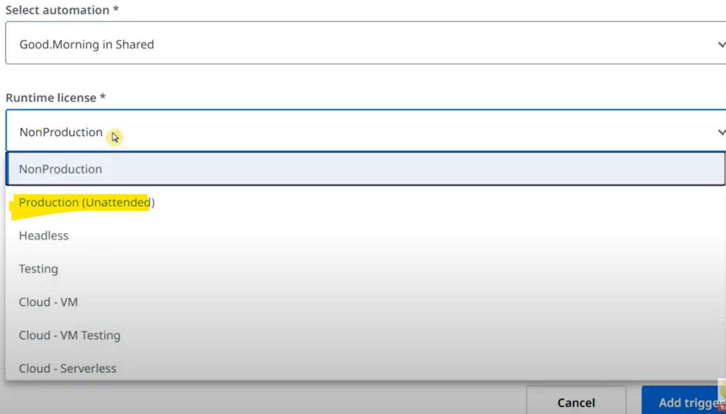

We have many other data filters to choose but for now we are keeping it simple.

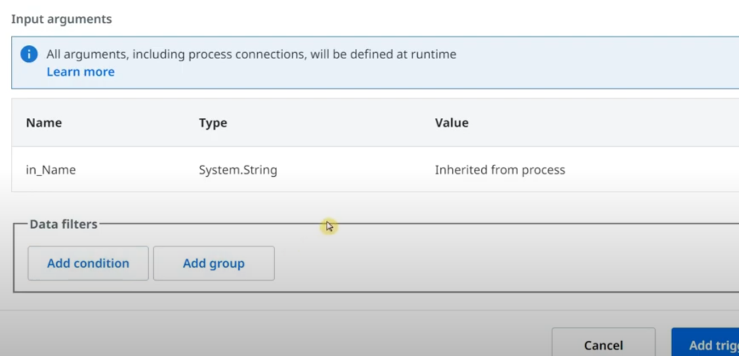

The created trigger looks like below.

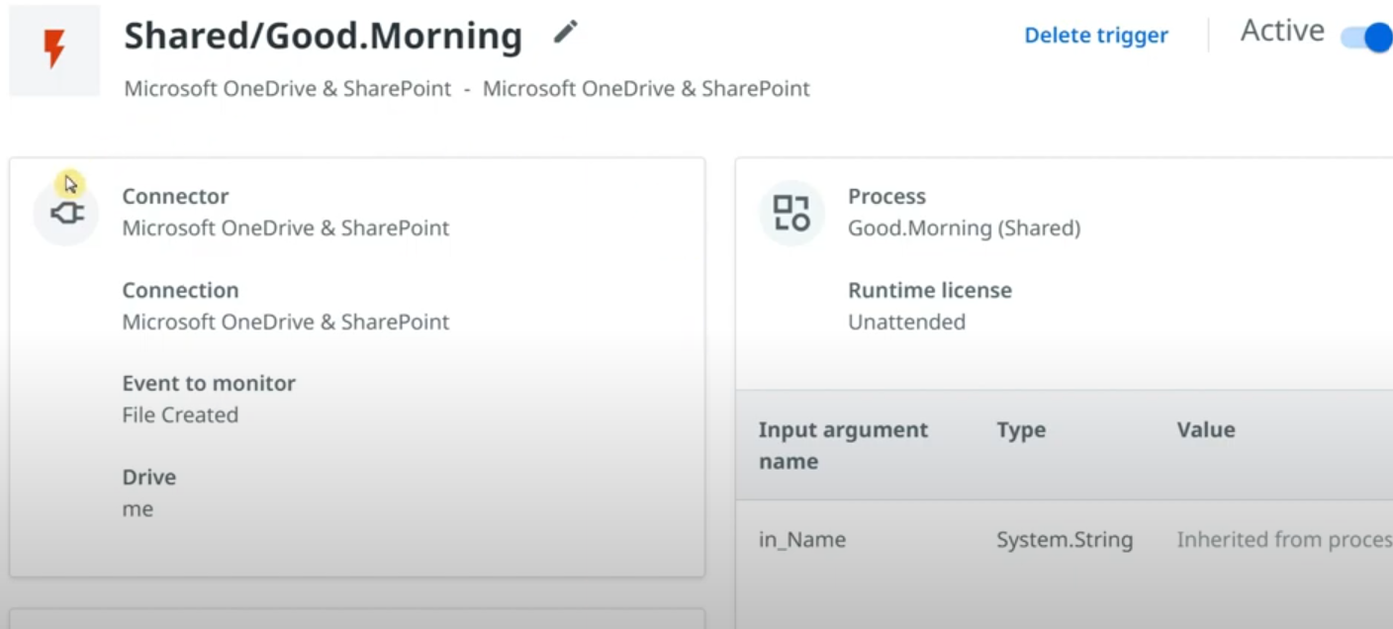

Polling time: By default this trigger will be checked for every 5 minutes. To change polling time, click on the connection.

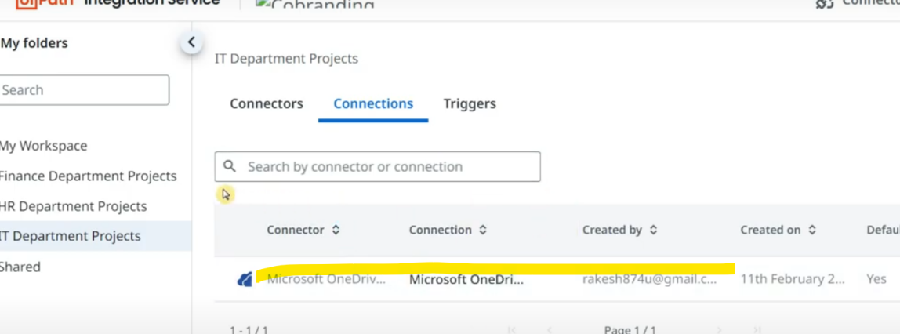

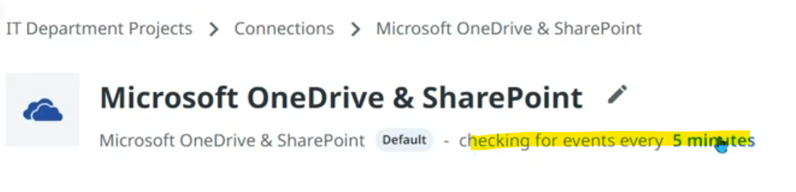

Click on Custom & write 1 minute.

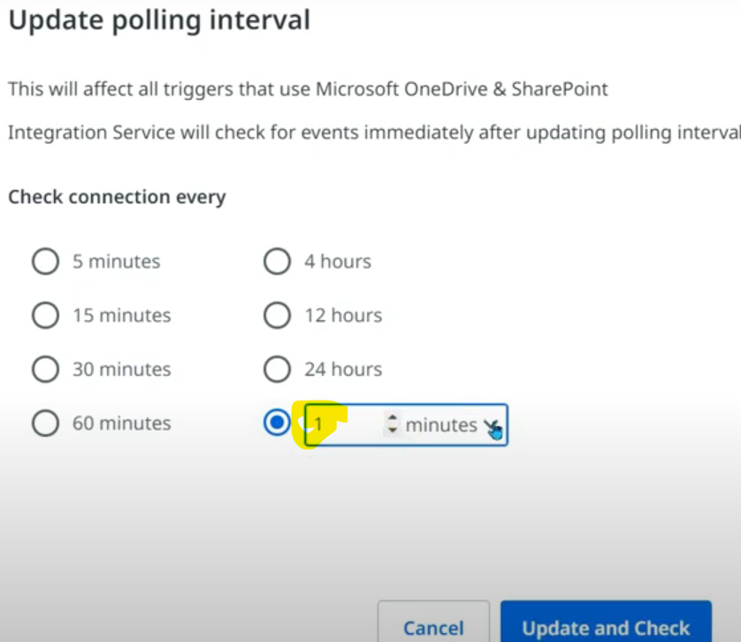

Now the trigger is set to check every 1 minute if file is created. Let's create file in OneDrive. Automation got executed & we see message box appeared.

Create few more files - word, ppt, pdf etc to check the trigger performance.

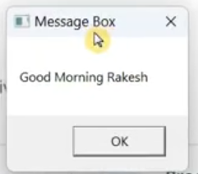

Under the trigger, you can view the history of trigger runs.

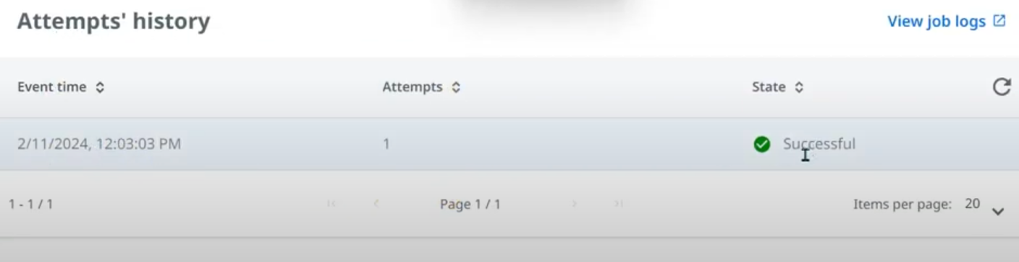

If automation isn't starting automatically even after trigger is set, there's a possibility that assistant might not be connected properly to the orchestrator.